Project Planning Phase
Project Planning Template (Product Backlog, Sprint Planning, Stories, Story points)

Date | 18 October 2026
Team ID | --------------------
Project Name | Car Rental Request Automation in ServiceNow Using Service Catalog and Workflows
Maximum Marks | 5 Marks

Product Backlog, Sprint Schedule, and Estimation (4 Marks)
Product backlog and sprint schedule for the Car Rental Request Automation project (26 user stories across 6 epics, estimated in story points 1, 2, 3 and 5).
Sprint | Functional Requirement (Epic) | User Story Number | User Story / Task | Story Points | Priority | Team Members
Sprint-1 | Requirement Analysis & Planning | USN-1 | As a project owner, I can define the business objectives for automating car rental requests. | 2 | High | Vamsi Bhavirisetti
Sprint-1 |  | USN-2 | As a project owner, I can define the functional scope (catalog item, form, approvals, tasks, notifications, SLA). | 2 | High | Vamsi Bhavirisetti
Sprint-1 |  | USN-3 | As a project owner, I can map stakeholders (requesters, managers, transport team, admins) and their needs. | 1 | Medium | Vamsi Bhavirisetti
Sprint-1 |  | USN-4 | As a project owner, I can prepare the execution roadmap with milestones for each phase. | 1 | Medium | Vamsi Bhavirisetti
Sprint-1 | Backend Development & Configurations (Data Architecture) | USN-5 | As an admin, I can create an Update Set to track all configurations for deployment. | 1 | High | Vamsi Bhavirisetti
Sprint-1 |  | USN-6 | As an admin, I can design the data architecture (REQ, RITM, SCTASK, approvals and Car Inventory table). | 3 | High | Vamsi Bhavirisetti
Sprint-1 |  | USN-7 | As an employee, I can use a 'Car Rental Request' catalog item with variables (Requested Date, Pickup Location, Drop Location, Duration, Car Type, Reason). | 3 | High | Vamsi Bhavirisetti
Sprint-1 |  | USN-8 | As an admin, I can configure Business Rules to auto-assign tasks and update request status after approvals. | 3 | High | Vamsi Bhavirisetti
Sprint-2 |  | USN-9 | As a manager, I receive an approval request through the flow (primary Manager Approval) when a car rental request is submitted. | 3 | High | Vamsi Bhavirisetti
Sprint-2 |  | USN-10 | As an approver, I can give a secondary Car Request Approval after the flow checks car availability. | 3 | High | Vamsi Bhavirisetti
Sprint-2 |  | USN-11 | As a transport team member, I receive an assignment task (SCTASK) for every approved request. | 2 | High | Vamsi Bhavirisetti
Sprint-2 |  | USN-12 | As a user, I receive email notifications at each stage (submitted, approved, assigned, closed). | 2 | Medium | Vamsi Bhavirisetti
Sprint-2 |  | USN-13 | As an admin, I can attach the workflow to the catalog item so every request follows the defined process. | 2 | High | Vamsi Bhavirisetti
Sprint-2 | UI/UX Development & Customization | USN-14 | As an employee, I can submit requests through a clean, user-friendly catalog form. | 2 | Medium | Vamsi Bhavirisetti
Sprint-2 |  | USN-15 | As a user, I can follow a clear navigation flow from catalog item to REQ, RITM and approval status. | 2 | Medium | Vamsi Bhavirisetti
Sprint-2 |  | USN-16 | As a user, I can see tooltips and help text on form fields for easy usage. | 1 | Low | Vamsi Bhavirisetti
Sprint-2 |  | USN-17 | As an employee, I get mandatory-field checks and auto-fill through client scripts while filling the form. | 3 | High | Vamsi Bhavirisetti
Sprint-3 | Data Migration, Testing & Security | USN-18 | As an admin, I can migrate existing car rental data into the new ServiceNow structure. | 3 | Medium | Vamsi Bhavirisetti
Sprint-3 |  | USN-19 | As an admin, I can enforce role-based access so only the right roles view or approve requests. | 3 | High | Vamsi Bhavirisetti
Sprint-3 |  | USN-20 | As an admin, I can enforce data integrity so no request moves forward without the required approvals. | 3 | High | Vamsi Bhavirisetti
Sprint-3 |  | USN-21 | As a tester, I can run QA tests on submission, approval routing, task creation and fulfillment. | 5 | High | Vamsi Bhavirisetti
Sprint-3 |  | USN-22 | As an admin, I can troubleshoot using flow execution logs and validate email notifications. | 3 | Medium | Vamsi Bhavirisetti
Sprint-4 | Deployment, Documentation & Final Presentation | USN-23 | As an admin, I can complete the Update Set, retrieve it in the target instance, preview and commit it. | 3 | High | Vamsi Bhavirisetti
Sprint-4 |  | USN-24 | As a tester, I can validate the full request flow in the target instance after deployment. | 2 | High | Vamsi Bhavirisetti
Sprint-4 |  | USN-25 | As a stakeholder, I can read technical and user documentation of the solution. | 3 | Medium | Vamsi Bhavirisetti
Sprint-4 | Project Conclusion | USN-26 | As a stakeholder, I can see a final presentation and project conclusion of the working system. | 2 | Medium | Vamsi Bhavirisetti
Project Tracker, Velocity & Burndown Chart: (4 Marks)
Sprint | Total Story Points | Duration | Sprint Start Date | Sprint End Date (Planned) | Story Points Completed (as on Planned End Date) | Sprint Release Date (Actual)
Sprint-1 | 16 | 6 Days | 26 Oct 2026 | 31 Oct 2026
Sprint-2 | 20 | 6 Days | 02 Nov 2026 | 07 Nov 2026
Sprint-3 | 17 | 6 Days | 09 Nov 2026 | 14 Nov 2026
Sprint-4 | 10 | 6 Days | 16 Nov 2026 | 21 Nov 2026
Velocity:
The project has 4 sprints of 6 days each. Total story points = 16 + 20 + 17 + 10 = 63. Velocity = Total story points / Number of sprints = 63 / 4 = 15.75, approximately 16 story points per sprint. Average velocity (AV) per day = Velocity / Sprint duration = 16 / 6 = 2.67 story points per day.

Burndown Chart:
A burndown chart is a graphical representation of work left to do versus time. The chart below shows the planned burndown of the 26 stories (63 story points) over the four sprints.
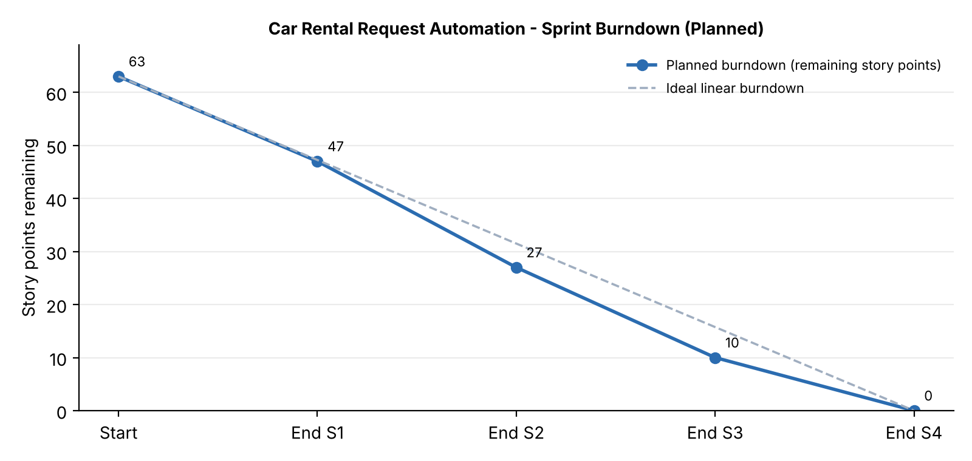
https://www.visual-paradigm.com/scrum/scrum-burndown-chart/
https://www.atlassian.com/agile/tutorials/burndown-charts
Reference:
https://www.atlassian.com/agile/project-management
https://www.atlassian.com/agile/tutorials/how-to-do-scrum-with-jira-software
https://www.atlassian.com/agile/tutorials/epics
https://www.atlassian.com/agile/tutorials/sprints
https://www.atlassian.com/agile/project-management/estimation
https://www.atlassian.com/agile/tutorials/burndown-charts

